SUBJECT LINE: Tips and tools to help manage your money and reach your goals

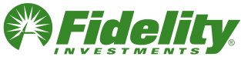 | 

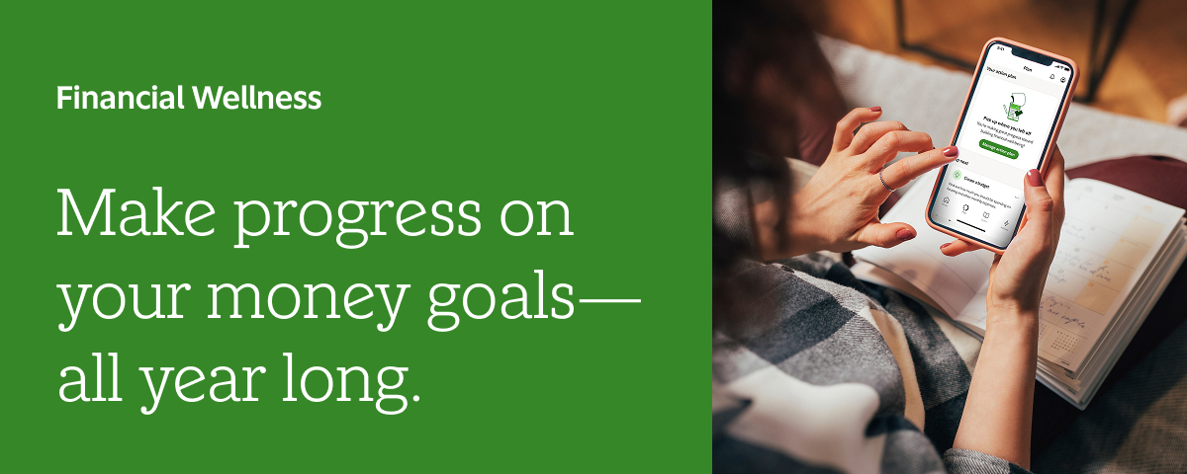
Financial wellness is different for everyone. But no matter how you define it, there are resources that can help you make it happen. When you visit your financial wellness dashboard on NetBenefits®, you get a clear view of where you stand, plus tips to help you understand your spending, create a plan, and track progress toward your money goals—all with personalized insights to fit your life.



The financial wellness dashboard can help you do the following:
- See where you are with the Financial Wellness Checkup or check in with your action plan
- <Prep and plan for the unexpected with Fidelity Goal BoosterSM>
- Organize your finances and make decisions with tools and resources

 | 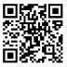 | The NetBenefits® app gives you more ways to access and manage your employee benefits. Download or open the app.
App Store is a registered service mark of Apple Inc.
Google Play is a registered trademark of Google LLC.

Privacy Policy | Terms of Use
Investing involves risk, including risk of loss.

Images are for illustrative purposes only.

<[If including Goal Booster] Fidelity retail products and services are offered separately from your employer-sponsored retirement plan.>

The information in this email is intended solely for the attention and use of the named addressee. This message or any part thereof must not be disclosed, copied, distributed, or retained by any person without authorization of the addressee.

Please do not respond to this email. This mailbox is not monitored, and you will not receive a response.

NetBenefits, Fidelity, and the Fidelity Investments logo are registered service marks of FMR LLC. <[If including Goal Booster] Fidelity Goal Booster is a service mark of FMR LLC.>
Fidelity Brokerage Services LLC, Member NYSE, SIPC, 900 Salem Street, Smithfield, RI 02917
© 2025 FMR LLC. All rights reserved.
1191781.2.1

